Bleasby
Local
History
Society
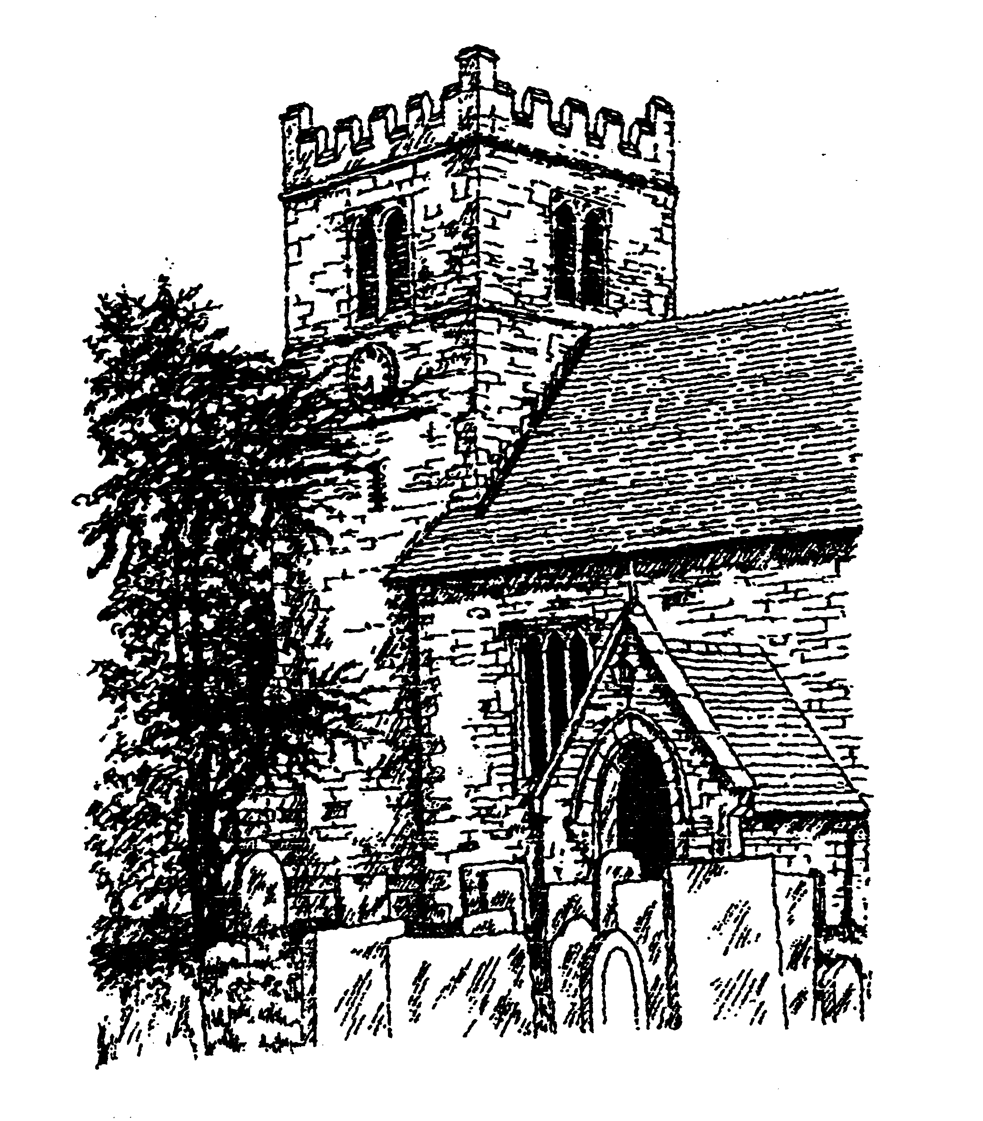

Tuesday 25th March 2025 - 7.30pm in Bleasby Village Hall, Gypsy Lane
Annual General Meeting
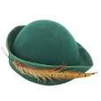 “Hats Off to BLHS” 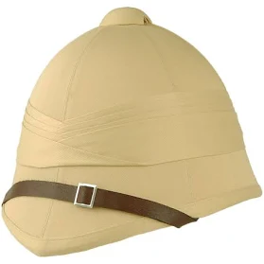

A short review of the past year followed by “Who wore that hat” – bring along any hat which was worn for a special family, occupational or historical reason or by some interesting person!

If you contribute a refreshing drink the Society will provide the biscuits!

It’s also the time we renew our membership
and welcome new members!

