Bleasby
Local
History
Society
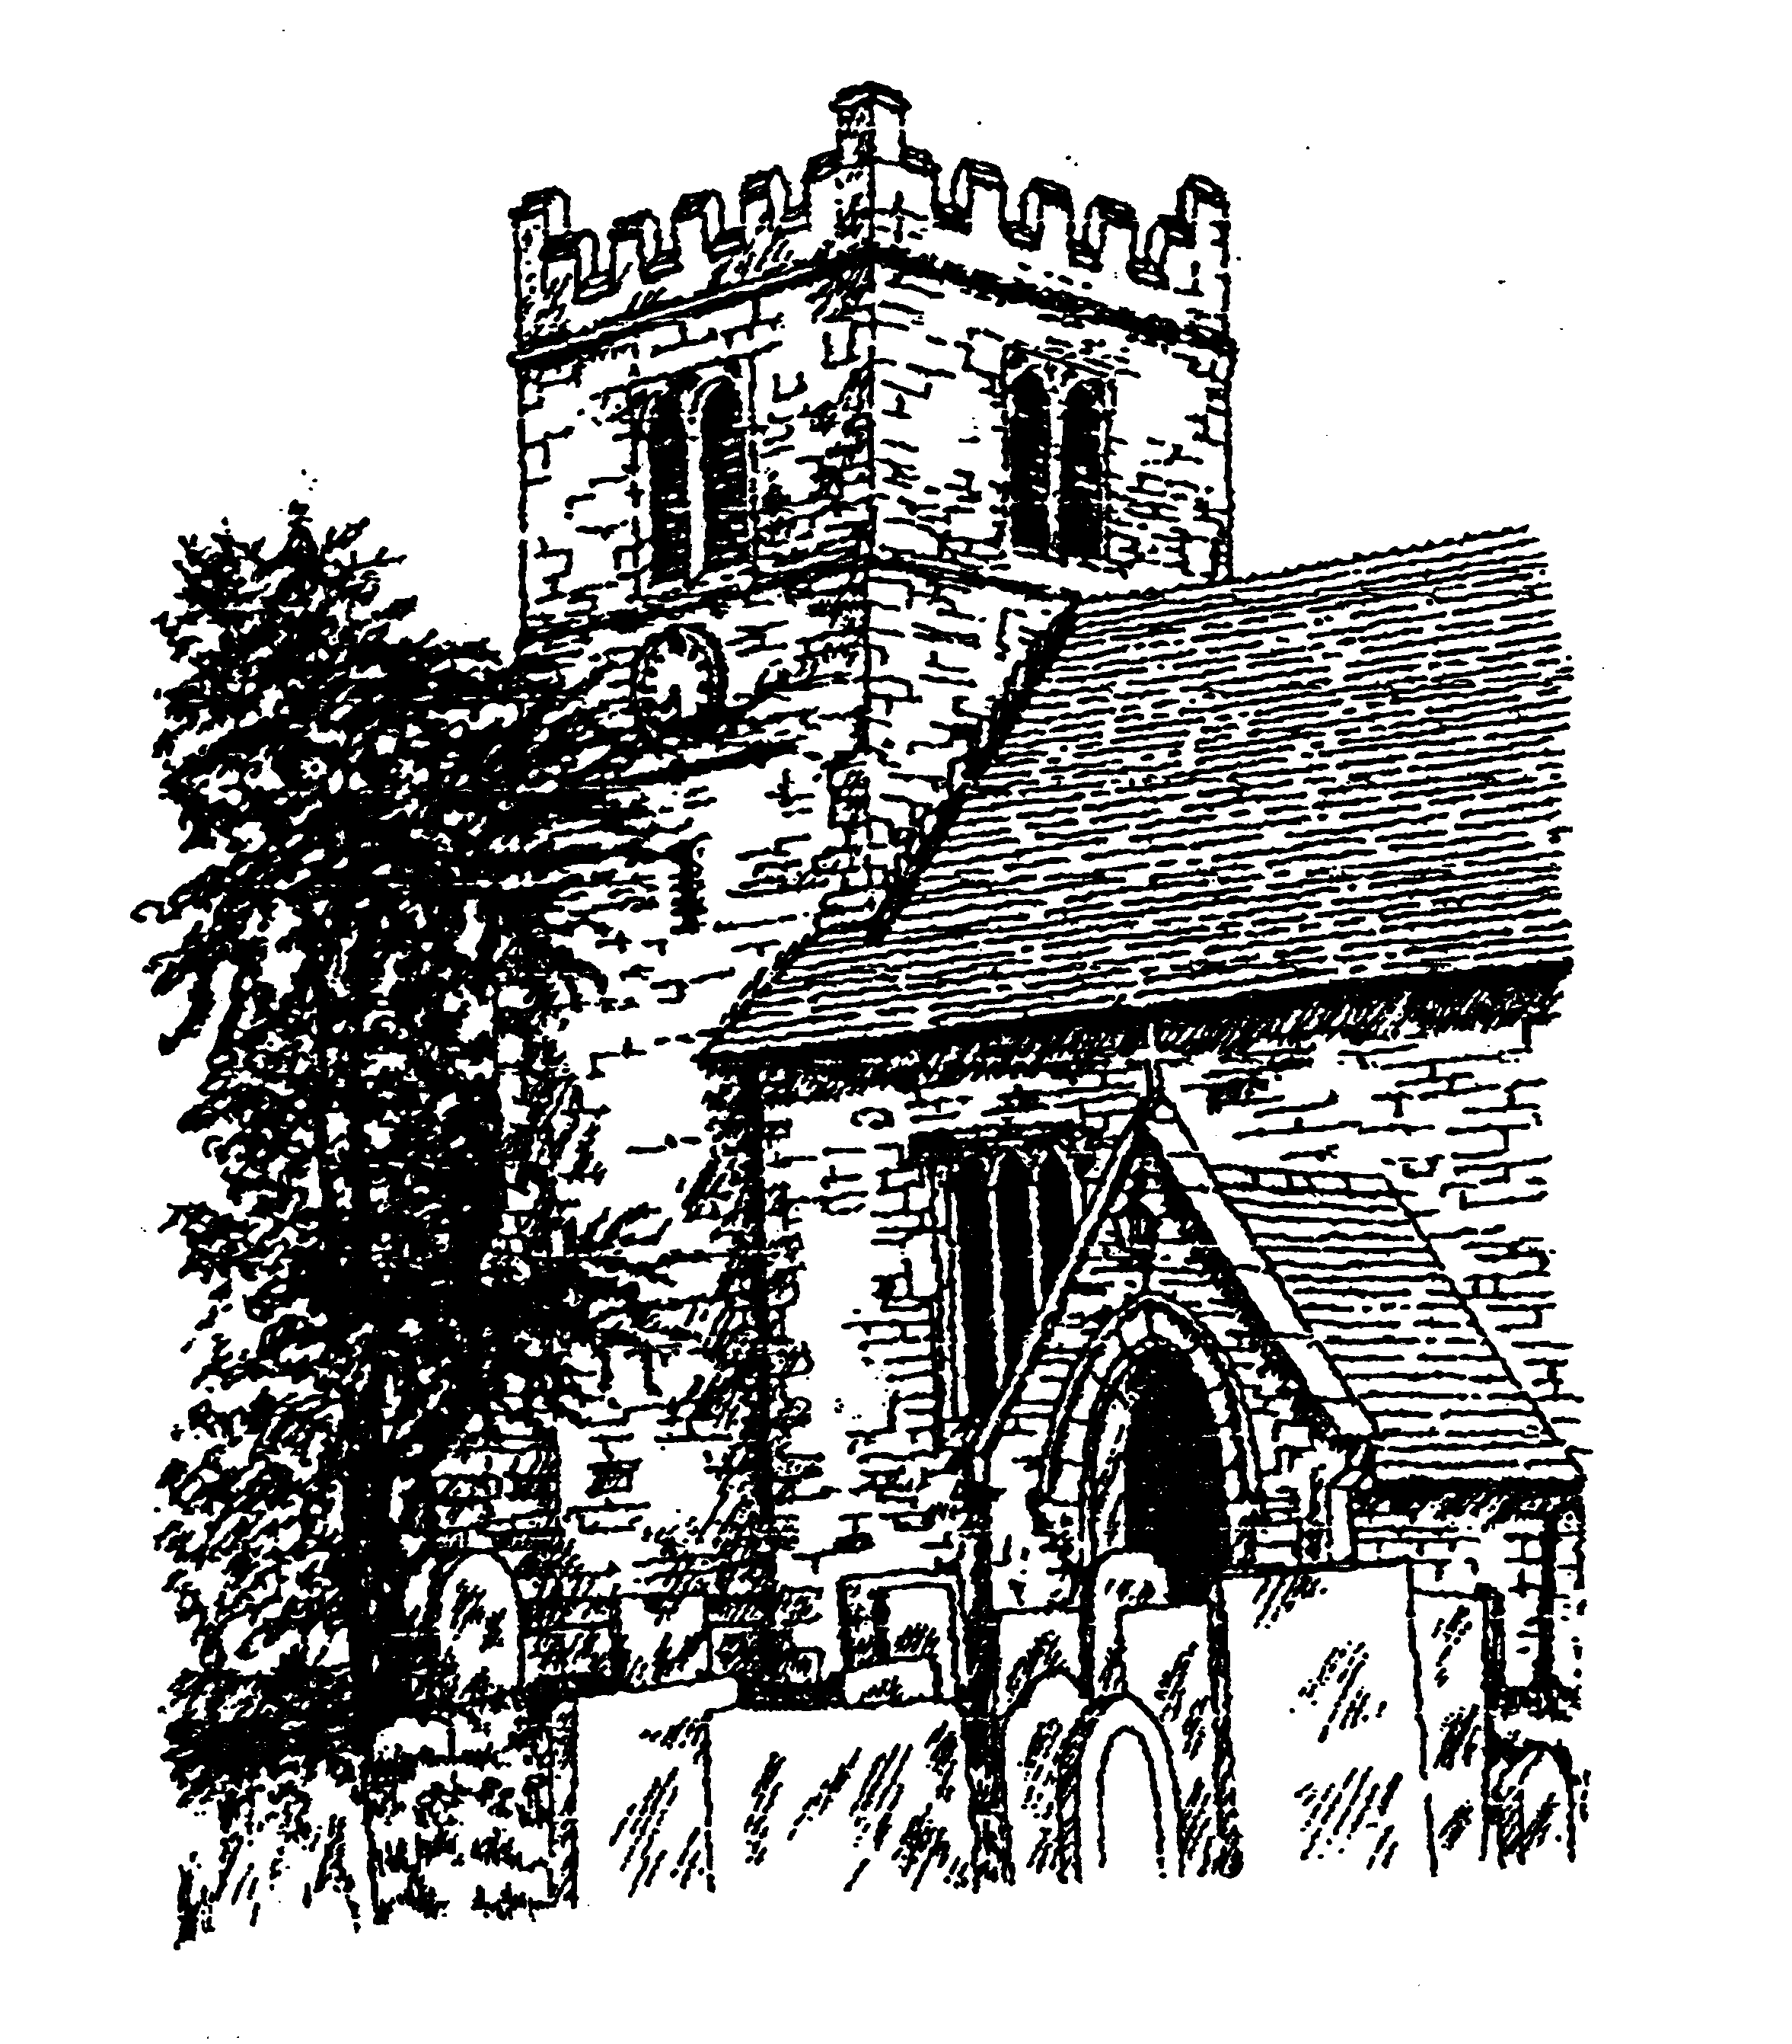

Tuesday 28th January 2025
7.30pm in Bleasby Village Hall

Richard Parker on the Norton Disney Iron Age & Roman site and its recent very special find – the Dodecahedron!

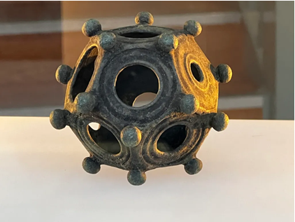
Modest fee requested from non-members

