Bleasby
Local
History
Society
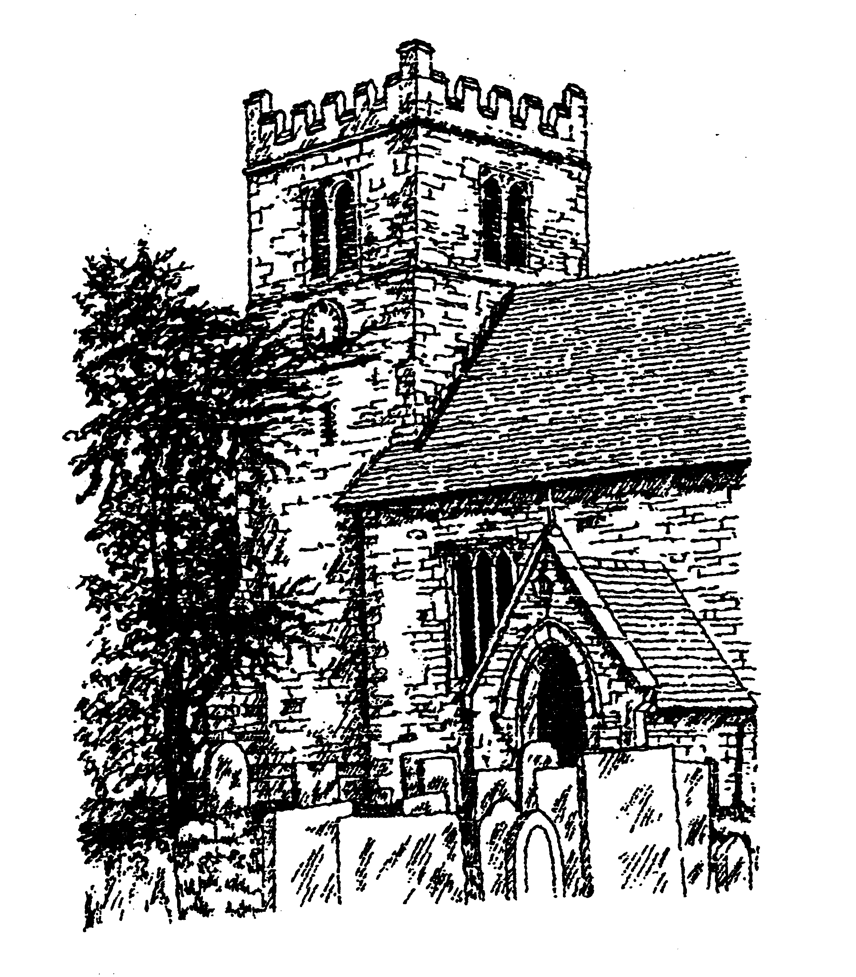

Tuesday 26th November 2024
7.30pm in Bleasby Village Hall

In Wartime Skies Over Bleasby

Our own Ken Ogilvie is giving us what will be an excellent very local interest lecture
​
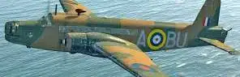 Wellington
Lancaster 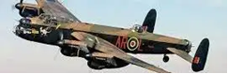
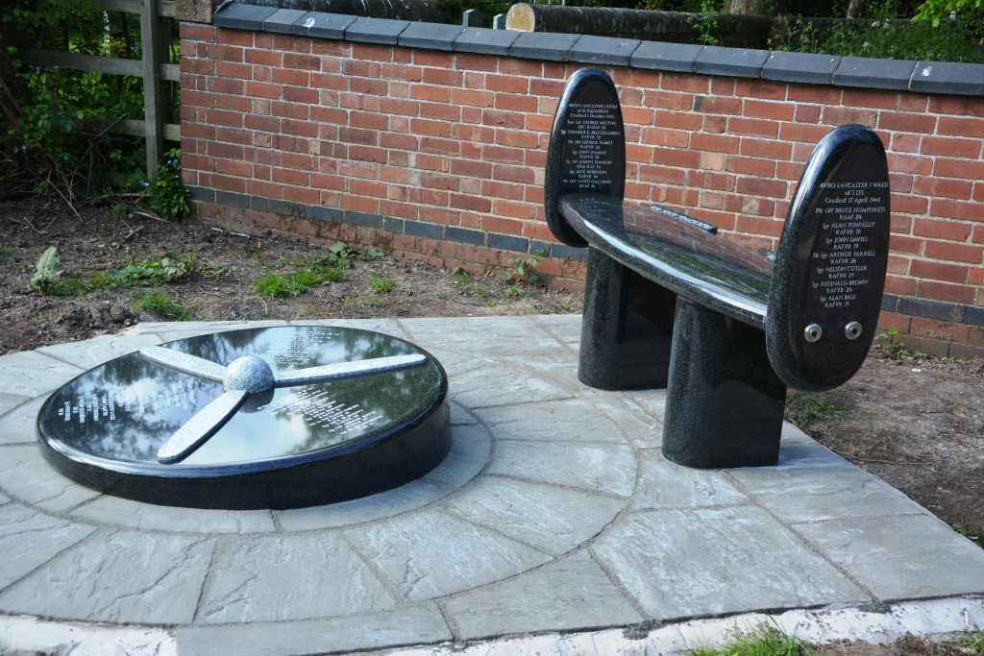 Modest fee requested from non-members

