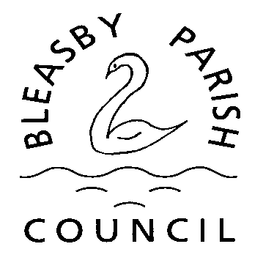

bleasbyparishcouncil@outlook.com

Application for use of Glebe Field, Bleasby for special Events

Name of Person organising the event …………………………………………………

Name of organisation (if relevant) …………………………………………………………………………

Address ………………………………………………………………………………………………………
…………………………………………………………………………………………………………………..
Telephone Contact………………………………………………………………………………………….
Email ………………………………………………………………………………………………………….

Date of event……………………..……………. Time of event ………………………………….

Event Details……………………………………………………………………………

If this is a fund-raising event, which charity/charities will benefit……………………………….

Insurance Provider name ………………………………………………………….

Policy Number…………………………………………

Date of cover…………………………………………..

A Risk Assessment must be provided with a copy of Insurance details before the event

…………………………………………………………………………………………………………..
Please sign here to confirm that you have read and agree to the
conditions of use of the Glebe Field. The decision of the Parish Council is final on all matters relating to the Glebe Field.

Please note that dogs are not permitted on the Glebe Field, except registered assistance dogs – for safety reasons glass drinking glasses are not to be taken on to the field.

